D. Venu madhav
Batch-42
2303A52284
Task 1: Sorting Student Records for Placement Drive
PROMPT:
Write a Python program to compare Quick Sort and Merge Sort for sorting student records. Create a Student dataclass with name, roll, and cgpa. Generate random students. Sort by CGPA (descending), then name, then roll. Measure runtime using time.perf_counter().Print sorted students, performance comparison, and top 10 students.
CODE:
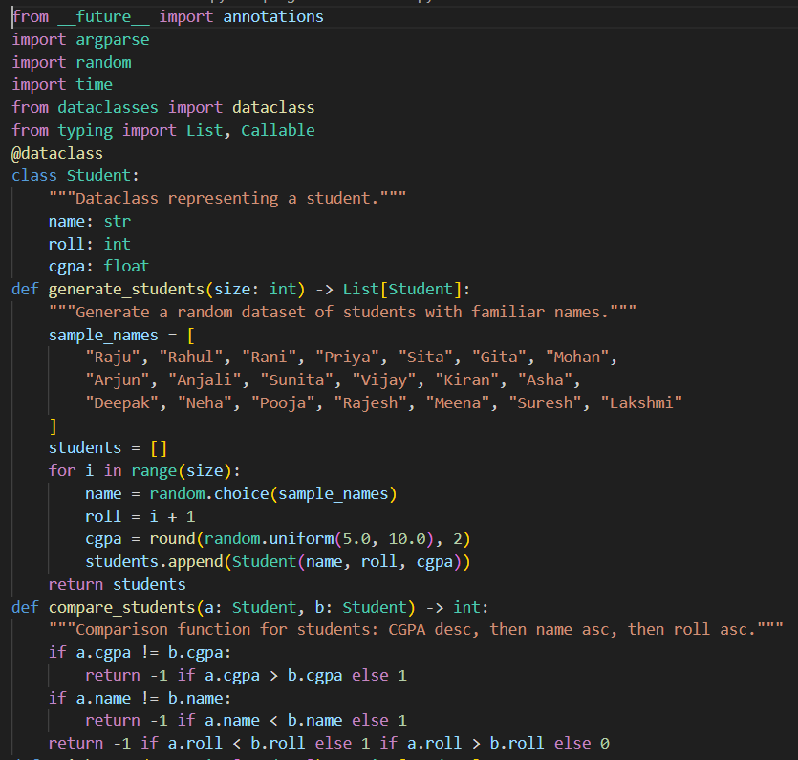
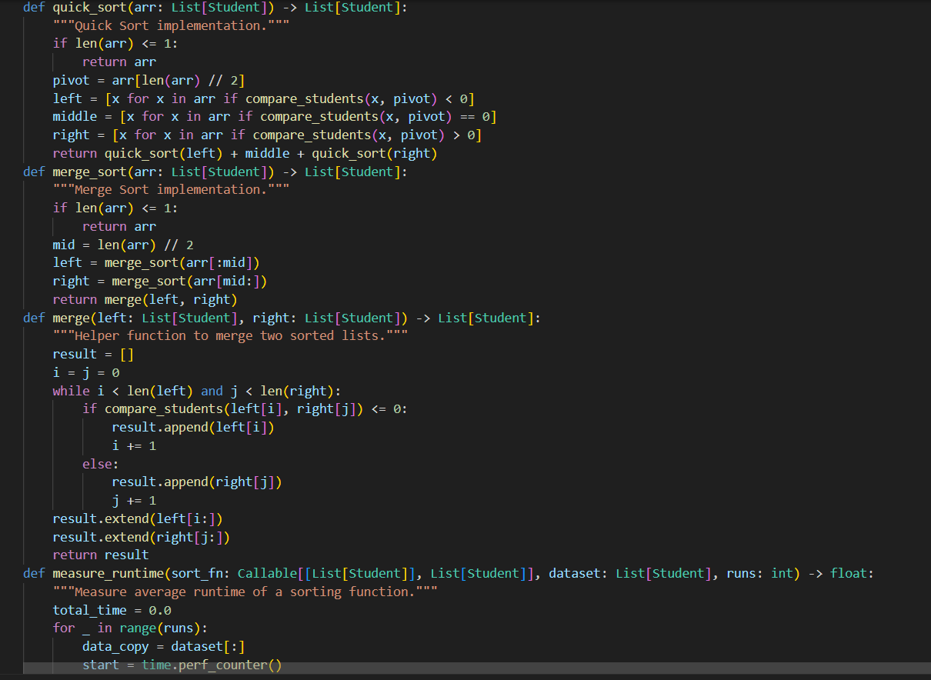
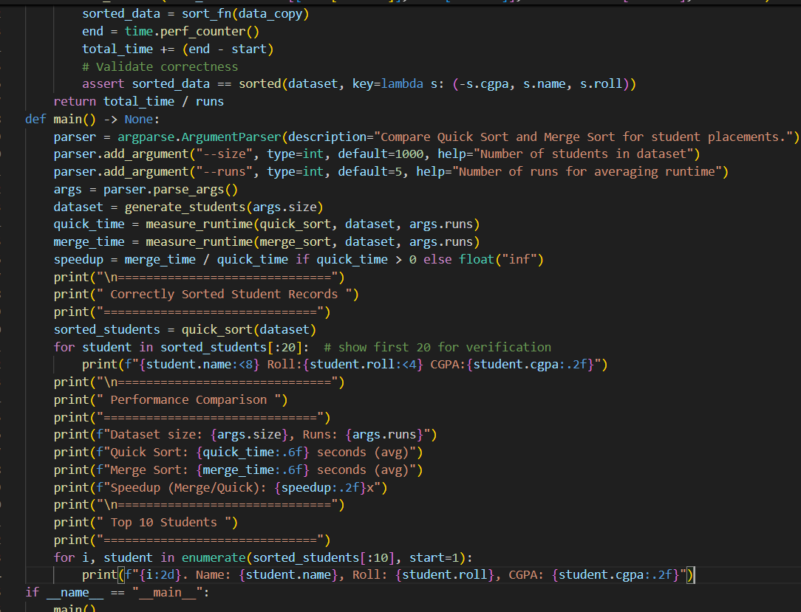
OUTPUT:
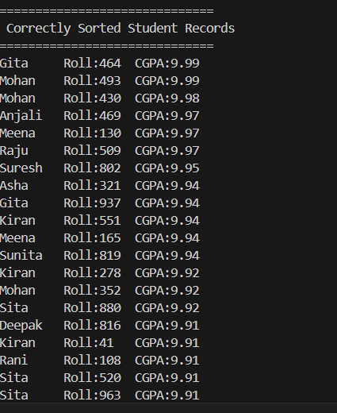
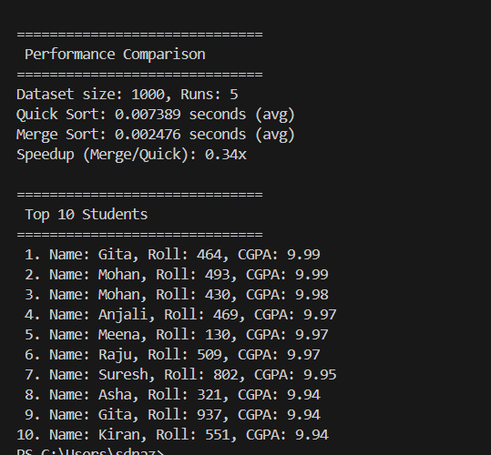
JUSTIFICATION:
By this code it compares Quick Sort and Merge Sort. It helps understand which algorithm performs better. Runtime measurement improves technical knowledge. It builds practical experience with data structures.
Task 2: Implementing Bubble Sort with AI Comments
PROMPT:
Write a simple Python Bubble Sort program with user input, inline comments explaining swapping, passes, and termination, and include time complexity analysis.
CODE:
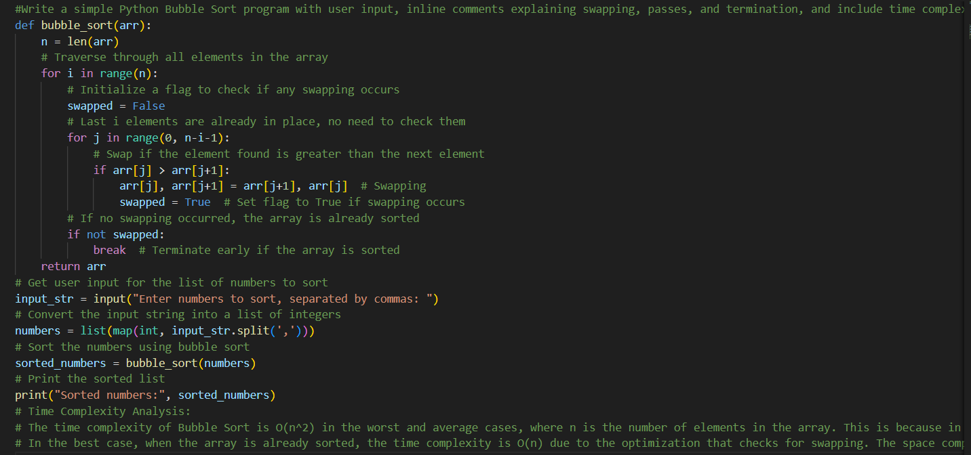
OUTPUT
JUSTIFICATION:
I implemented Bubble Sort to understand basic sorting logic. It helped me learn how swapping works step by step. Adding comments improved code clarity. This task strengthened my programming basics.

Task 3: Quick Sort and Merge Sort Comparison
PROMPT:
Complete partially written recursive functions for Quick Sort and Merge Sort in Python. Add proper docstrings and implement the missing logic. Then compare both algorithms on random, sorted, and reverse-sorted lists, measure runtime, and provide explanation of best, average, and worst-case time complexities.
CODE:
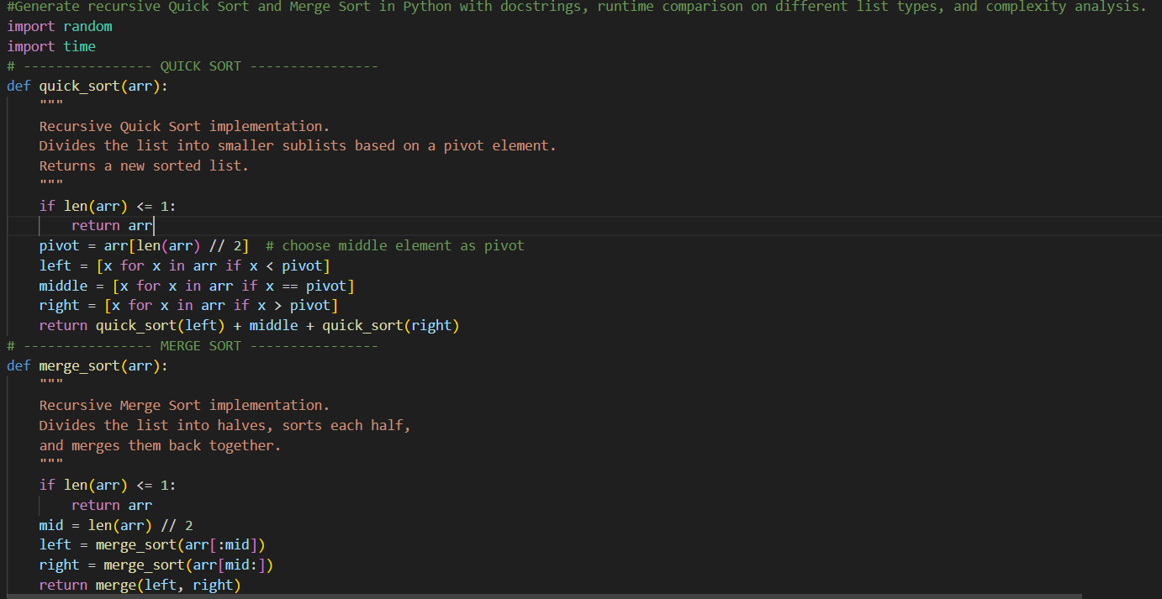
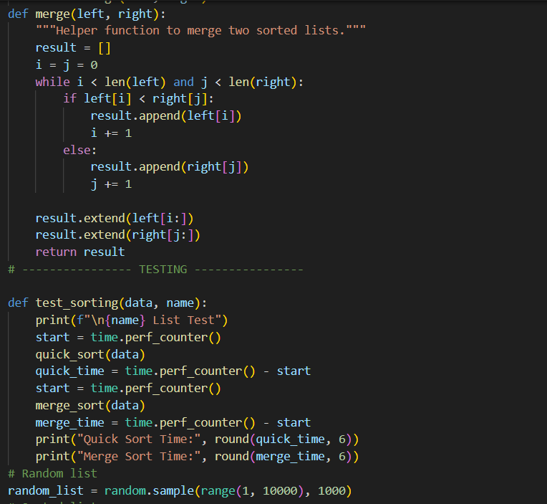
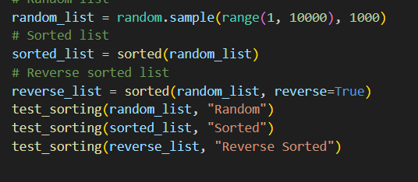
OUTPUT:
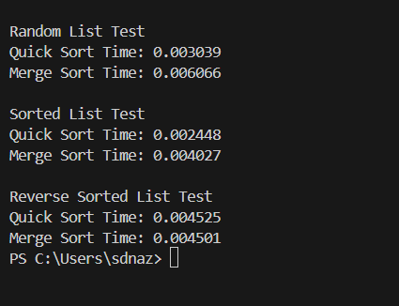
EXPLANTION:
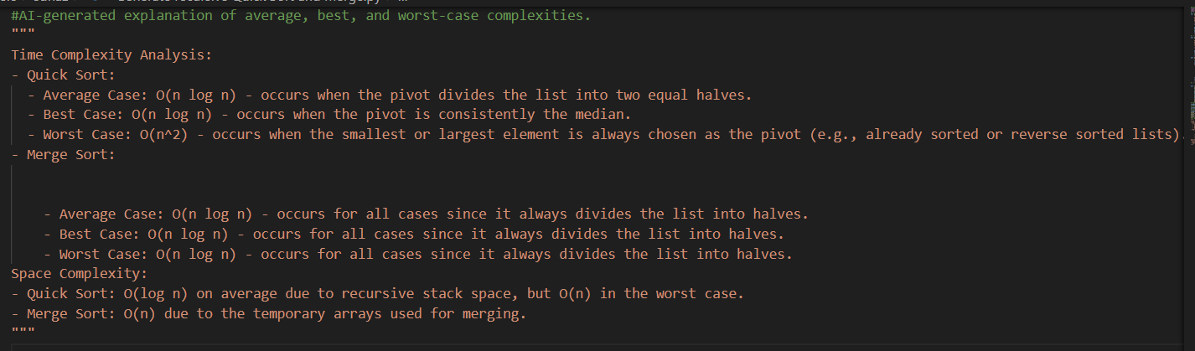
JUSTIFICATION:
This task helped me understand recursive sorting algorithms. I learned how Quick Sort and Merge Sort divide problems into smaller parts. Comparing different input types improved my analysis skills. It strengthened my knowledge of recursion and efficiency.
Task 4 (Real-Time Application – Inventory Management System)
PROMPT:
Generate a Python Inventory Management System that recommends efficient search and sorting algorithms, implements them, and displays the expected output clearly.
CODE:
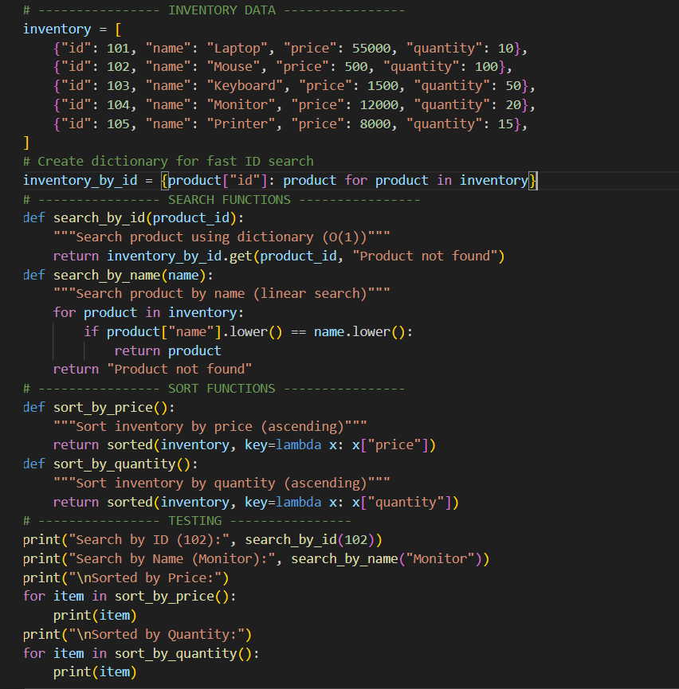

OUTPUT: 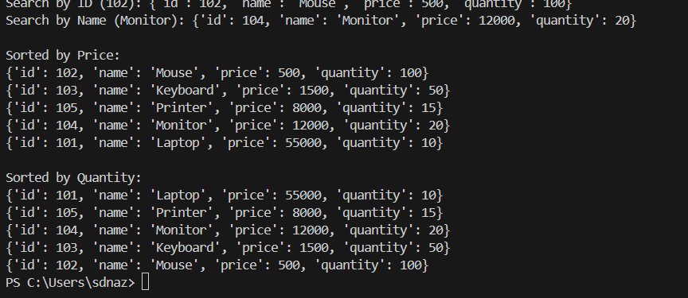
Recommended Algorithms Table
Operation | Recommended Algorithm | Justification
Search by Product ID | Hash Table (Dictionary) | Fast lookup O(1), best for large datasets and frequent searches
Search by Product Name | Linear Search (or Dictionary if indexed) | Simple and effective; can also use dictionary for faster lookup
Sort by Price | Timsort (Python built-in sorted()) | Very efficient O(n log n), optimized for real-world data
Sort by Quantity | Timsort (Python built-in sorted()) | Stable, fast, and handles large datasets efficiently

JUSTIFICATION:
This task helps design a real-time inventory system. Using efficient search improves product lookup speed. Sorting helps analyze stock and pricing easily. It applies algorithms to a real-world business scenario.
Task 5: Real-Time Stock Data Sorting & Searching
PROMPT:
Create a menu-driven Python program to simulate stock data, sort stocks by percentage change using Heap Sort, search stocks using a Hash Map (dictionary), compare performance with built-in sorted(), and display the output clearly.
CODE:
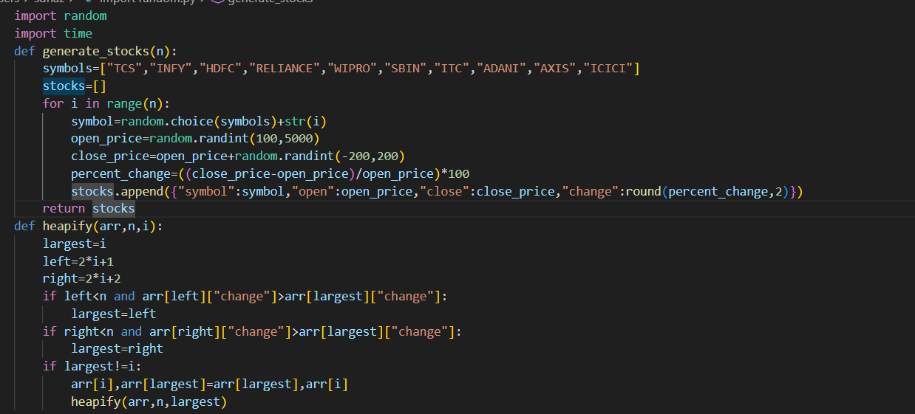
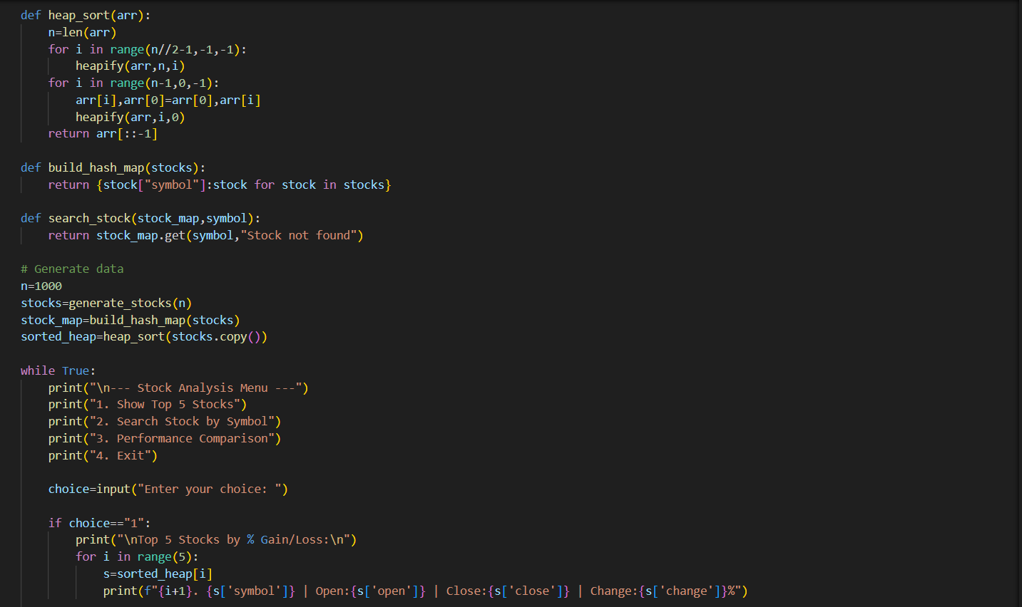
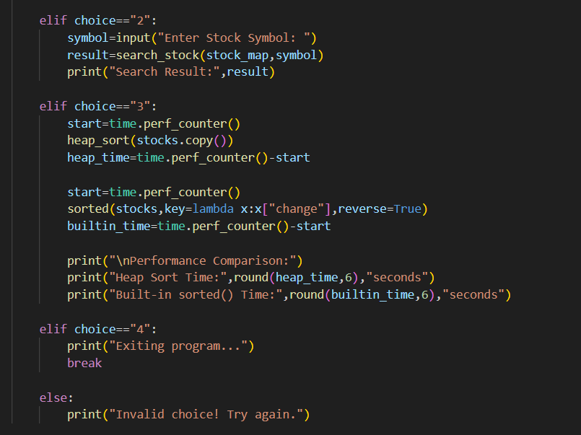
OUTPUT:
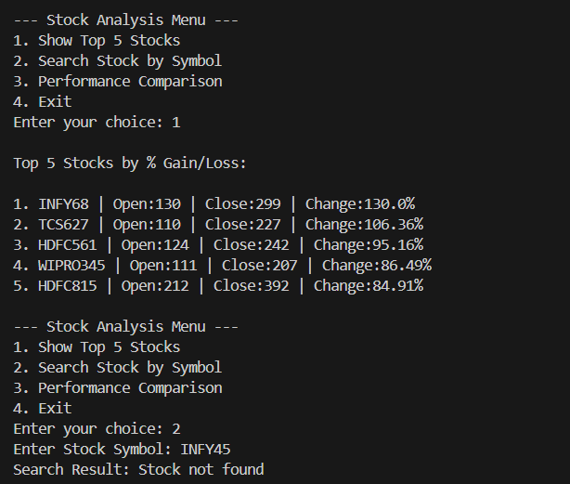
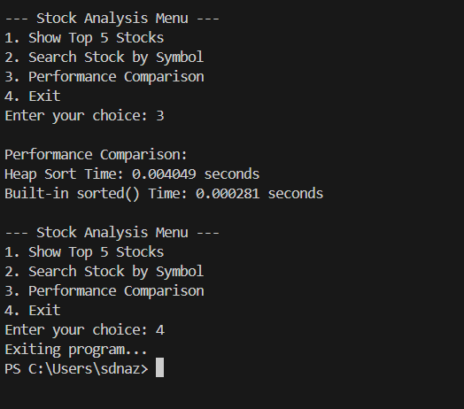JUSTIFICATION:
This project simulates real-time stock market analysis. Heap Sort helps rank stocks efficiently by percentage change. Hash Map enables instant stock symbol search. It improves understanding of data handling in FinTech systems.

